JH-JDS2062A Dual Channel Signal Generator Instruction Manual

Contents

Dual channel signal generator instruction manual
- Signal generator parameter description.......................................................................................1
- Product appearance description...................................................................................................2
- Product button description...........................................................................................................3
- Detailed functional interface........................................................................................................4
  - Short press the MENU button once: enter the basic configuration interface.............................4
  - Short press the MENU button twice: enter the frequency sweep configuration interface.........5
  - Short press the MENU button 3 times: enter the sweep configuration interface.......................6
  - Long press the MENU button: enter the custom waveform, sawtooth wave interface..............8
- Operation of product upgrades...................................................................................................9
- Custom waveform operation......................................................................................................9

- Signal generator parameter description

Sine wave | 0.01Hz ---- 30MHz (minimum resolution 0.01Hz)
Square wave | 0.01Hz ---- 25Mhz (minimum resolution 0.01Hz)
Triangle wave | 0.01Hz ---- 25Mhz (minimum resolution 0.01Hz)
Other waveform | 0.01Hz ---- 6MHz (minimum resolution 0.01Hz)
Custom waveform | 1Hz -----6MHz (minimum resolution 1Hz)
Square wave rise time | <= 10ns
Waveform type(Comes with) | Square wave, sine wave, triangle wave, trapezoidal wave, exponential wave, half-sine wave, positive and negative triangular wave, ringing wave, etc.
Custom waveform | 98 (the waveform drawn by the user himself)
Number of waveform points | 2048 (maximum)
Waveform maximum output frequency | 150MSa/s
Vertical resolution | 14 bits
Square wave overshoot | <=5%
Square wave duty cycle | 0%-100%
Output signal amplitude range | <=5MHz (2mV ---- 20V)
Output signal amplitude range | >=5MHz<=10MHz (2mV ---- 10V)
Output signal amplitude range | >=10MHz<=30MHz (2mV ---- 5V)
Minimum amplitude | 2mV
Minimum amplitude increment | 1mV
Output signal offset range | <=500mV (-+ 1V (total maximum))
Output signal offset range | >500mV (-+ 10V (total maximum))
Minimum offset increment | 1mV
Adjustable phase | 0°---- 360°
Minimum phase increment | 1°
Frequency sweep channel | CH1 CH2 (can be simultaneously)
Frequency sweep type | Linear
Frequency sweep time | 200ms --- 999.9s
Sweep time minimum step | 100ms
Predetermined area | Corresponding frequency of each self-contained waveform
Frequency sweep mode | Positive sweep, reverse sweep, return sweep
Sweep channel | CH1 CH2 (can be simultaneously)
Sweep type | Linear
Sweep time | 200ms --- 999.9s
Minimum step in sweep time | 100ms
Predetermined area | Corresponding amplitude of each self-contained waveform
Sweep mode | Positive sweep, reverse sweep, return sweep
Waveform output impedance | 50 Ω - +10%
Frequency meter | Input 1Hz ------ 100MHz (input voltage range 200mV-20V)

- Product appearance description

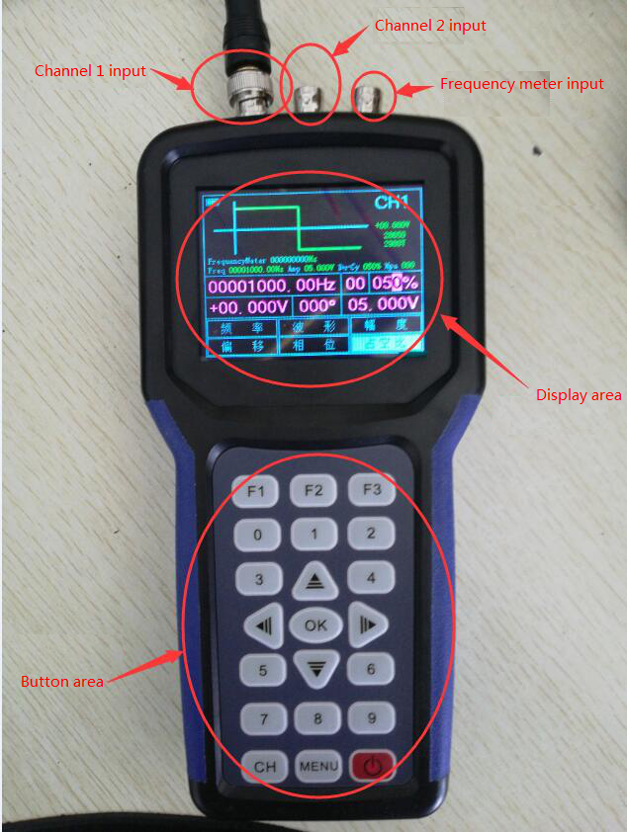

- Product button description
There are 21 buttons in this product, each button has different functions corresponding to different interfaces.
The main function keys have the following three:
Red button: power on and off function (both long press)
CH key: Switch CH1 configuration interface or CH2 configuration interface as shown below:
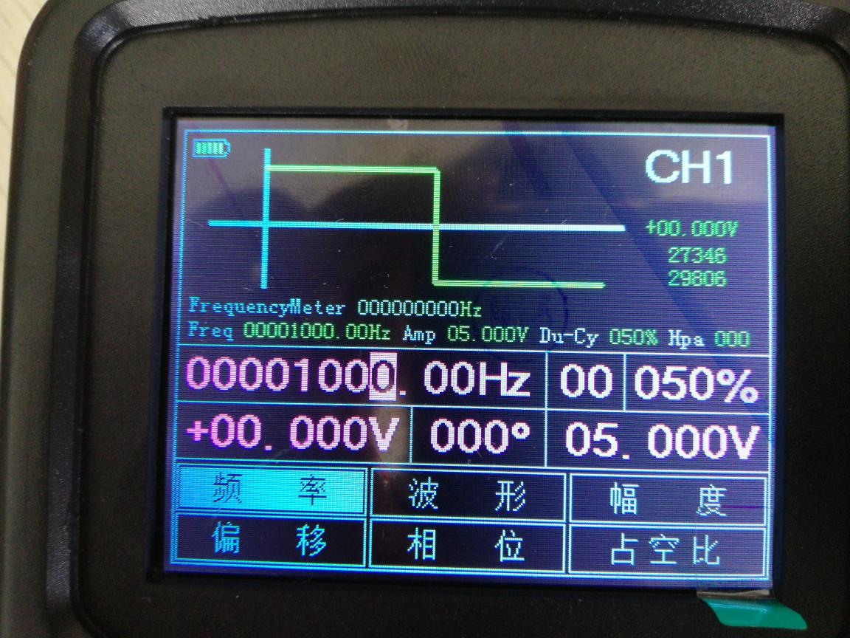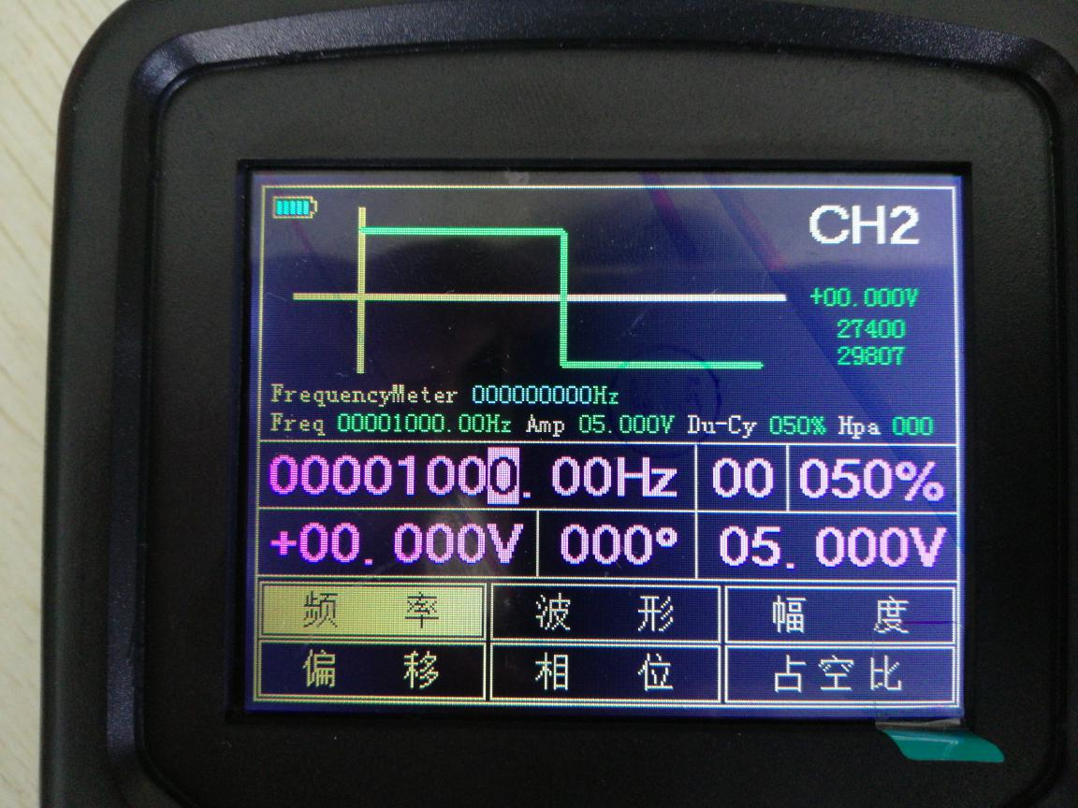
Since the CH1 and CH2 functions of the two products are identical in terms of functions, configuration, parameters, etc., the following descriptions all refer to the CH1 interface as the reference standard, and the CH2 operations are equivalent.

MENU button: Switch the function configuration interface corresponding to each channel.

- Detailed functional interface
The following describes each function configuration interface:
  - Short press the MENU button once: enter the basic configuration interface. As shown below:

Interface parameters:
FrequencyMeter------The corresponding frequency obtained by the frequency meter.
Freq-----Current output waveform frequency.
Amp-----The amplitude of the current output waveform.
Du-Cy-----The duty cycle of the current output waveform (this product duty cycle is only valid for the square wave).
Hpa-----The phase of the current output waveform.
+00.000V-----Offset of the current output waveform.
27346-----Median parameter 1.
29806-----Median parameter 2.
Note: The median parameter is used when customizing the waveform (fill in the corresponding position amd see below for details), the median parameter of each machine will be different.

The function description of the button under this interface:
F1: Switching frequency, offset parameter configuration.
F2: Switch waveform, phase parameter configuration.
F3: Switching amplitude, parameter configuration of duty cycle.
0-9: The corresponding number entered in the corresponding parameter configuration.
↑: Implement the number in the corresponding parameter configuration +.
↓: Implement numbers in the corresponding parameter configuration -.
←: Select the digital option in the corresponding parameter configuration.
→: Select the digital option in the corresponding parameter configuration.
OK: When all the parameters are configured, press the OK button to output the corresponding waveform.
  - Short press the MENU button twice: enter the frequency sweep configuration interface. As shown below:
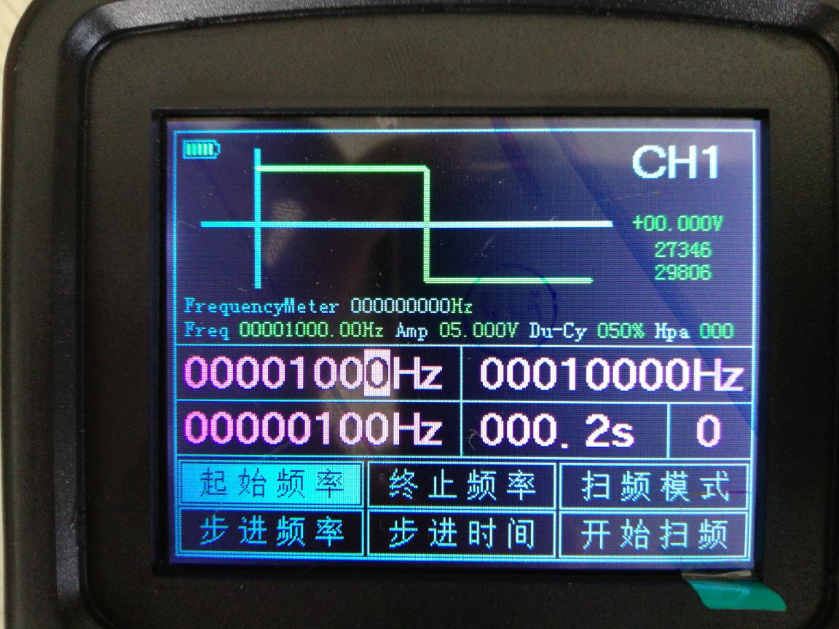
Interface parameters:
FrequencyMeter------The corresponding frequency obtained by the frequency meter.
Freq-----Current output waveform frequency.
Amp-----The amplitude of the current output waveform.
Du-Cy-----The duty cycle of the current output waveform (this product duty cycle is only valid for the square wave).
Hpa-----The phase of the current output waveform.
+00.000V-----Offset of the current output waveform.
27346-----Median parameter 1.
29806-----Median parameter 2.
Note: The median parameter is used when customizing the waveform (fill in the corresponding position amd see below for details), the median parameter of each machine will be different.

Description of each option:
Starting frequency | The sweep waveform starts to sweep from this frequency
Step frequency | Frequency sweep waveform: frequency of the waveform is added or subtracted at this frequency (+ operation is performed when the starting frequency is less than the ending frequency, and -operation is performed when the ending frequency is greater than the starting frequency).
Termination frequency | Sweep waveform with this frequency as the end point, repeat sweep
Step time | Sweep waveform to change its own frequency at this time
Sweep mode | 0 means that after the sweep reaches the termination frequency, it returns to the start frequency and sweeps again.  1 means that after the sweep frequency reaches the end frequency, the end frequency will be used as the starting point, and the starting frequency will be the end frequency for the reverse sweep, and will be repeated.
Start sweeping | Press the OK button to start or stop the sweep

The function description of the button under this interface:
F1: Switch the starting frequency and parameter configuration of the step frequency.
F2: switching termination frequency, parameter configuration of step time.
F3: Parameter configuration for switching sweep mode and sweep start stop.
0-9: The corresponding number entered in the corresponding parameter configuration.
↑: Implement the number in the corresponding parameter configuration +.
↓: Implement numbers in the corresponding parameter configuration -.
←: Select the digital option in the corresponding parameter configuration.
→: Select the digital option in the corresponding parameter configuration.
OK: When all the parameters are configured, press the OK button to output the corresponding sweep waveform.

Description of frequency scavenging: only relevant parameters of frequency and time can be configured in the interface of frequency sweeping. As for amplitude, duty ratio, phase and other parameters are configured in the basic configuration interface.

  - Short press the MENU button 3 times: enter the sweep configuration interface. As shown below:
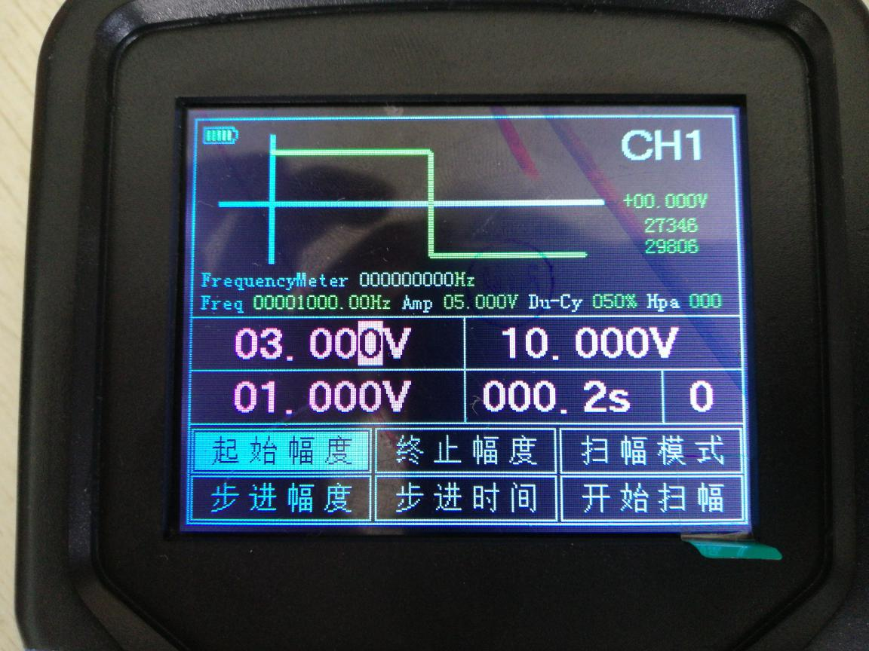

FrequencyMeter------The corresponding frequency obtained by the frequency meter.
Freq-----Current output waveform frequency.
Amp-----The amplitude of the current output waveform.
Du-Cy-----The duty cycle of the current output waveform (this product duty cycle is only valid for the square wave).
Hpa-----The phase of the current output waveform.
+00.000V-----Offset of the current output waveform.
27346-----Median parameter 1.
29806-----Median parameter 2.
Note: The median parameter is used when customizing the waveform (fill in the corresponding position amd see below for details), the median parameter of each machine will be different.

Description of each option:
Starting amplitude | The sweep waveform starts to sweep from this range
Step amplitude | The sweep waveform increases or decreases the waveform amplitude at this amplitude regularly (+ operation is performed when the starting amplitude is less than the ending amplitude, and -operation is performed when the ending amplitude is greater than the starting amplitude)
Termination of the amplitude | The sweep waveform is the end point of this amplitude, repeating the sweep
Step time | The sweep waveform changes its amplitude with this time.
Sweep mode | 0 means that after the sweep reaches the end of the range, the return amplitude is returned again.  1 means that after the sweep reaches the end of the range, the stop amplitude is taken as the starting point, the starting amplitude is the end point for the reverse sweep, and the cycle is repeated.
Start sweeping | Press OK to start or stop sweeping.

The function description of the button under this interface:
F1: Switching the starting amplitude and parameter setting of the stepping amplitude.
F2: switching termination amplitude, stepping time parameter configuration.
F3: Parameter configuration for switching the sweep mode and sweeping stop.
0-9: The corresponding number entered in the corresponding parameter configuration.
↑: Implement the number in the corresponding parameter configuration +.
↓: Implement numbers in the corresponding parameter configuration -.
←: Select the digital option in the corresponding parameter configuration.
→: Select the digital option in the corresponding parameter configuration.
OK: When all the parameters are configured, press the OK button to output the corresponding sweep waveform.
Description of sweeping: Only the amplitude and time related parameters can be configured in the sweeping interface. The parameters such as frequency, duty ratio and phase are all configured in the basic configuration interface.
  - Long press the MENU button: enter the custom waveform, sawtooth wave interface. As shown below:
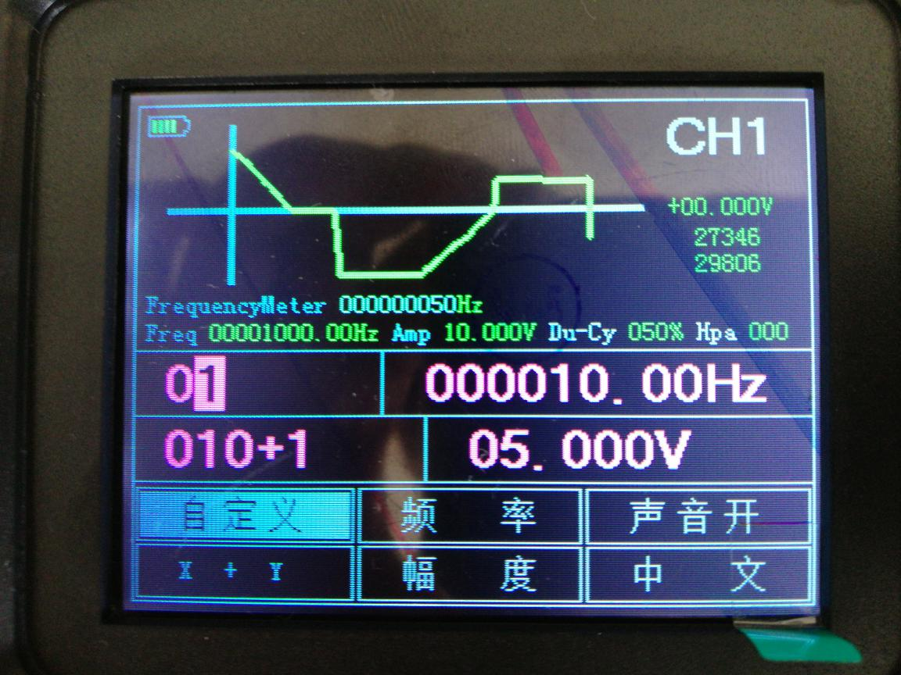

The function description of the button under this interface:
FrequencyMeter------The corresponding frequency obtained by the frequency meter.
Freq-----The frequency at which the custom waveform is currently output
Amp-----Current output custom waveform amplitude
Du-Cy-----The duty cycle of the current output custom waveform (this product duty cycle is only valid for the square wave).
Hpa-----Current phase of the custom waveform output.
+00.000V-----The offset of the current output custom waveform.
27346-----Median parameter 1.
29806-----Median parameter 2.
Note: The median parameter is used when customizing the waveform (fill in the corresponding positionand see below for details), the median parameter of each machine will be different.

Description of each option:
customize | 0-97 corresponds to each individual waveform number 98-string sawtooth wave, 99-wave sawtooth wave.
X-Y | Edit the structure of the corresponding sawtooth wave X to indicate the number of sine waves or square waves, and Y to represent the number of straight lines.
Frequency | Edit the frequency of the sawtooth wave.
Amplitude | Edit the amplitude of the sawtooth wave.
Sound switch | Control the sound on or off (shut down to save).
Chinese | Control menu displays Chinese or English (shut down to save).
The function description of the button under this interface:
F1: Switch the custom, X+Y parameter configuration.
F2: Parameter setting of switching frequency and amplitude.
F3: Switch the sound switch, parameter configuration of language selection.
0-9: The corresponding number entered in the corresponding parameter configuration.
↑: Implement the number in the corresponding parameter configuration +.
↓: Implement numbers in the corresponding parameter configuration -.
←: Select the digital option in the corresponding parameter configuration.
→: Select the digital option in the corresponding parameter configuration.
OK: The current option is a custom waveform (0-97) that outputs the corresponding number.
The current option is a custom-configured (98-99) sawtooth wave with output configuration. completed (98-string sawtooth, 99-wave sawtooth).
Switch the sound on or off when the current option is the sound switch.
When the current option is Chinese, switch Chinese, English display menu.

- Operation of product upgrades
Press and hold the OK button in the off state, then press the power button, it will enter the U disk mode. After connecting the computer with the usb cable, the U disk will appear, and the upgrade file updata.bin will be copied into the U disk (it is best to format it first). After the operation), press the MENU button to upgrade, and then restart after the upgrade is completed.

- Custom waveform operation
Important note: Custom waveforms must follow the principle of only one or a set of consecutive pixel information on the same Y-axis (pixel information on the same Y-axis is uninterruptible or otherwise invalid).

First open the software to enter the basic configuration interface.
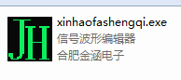

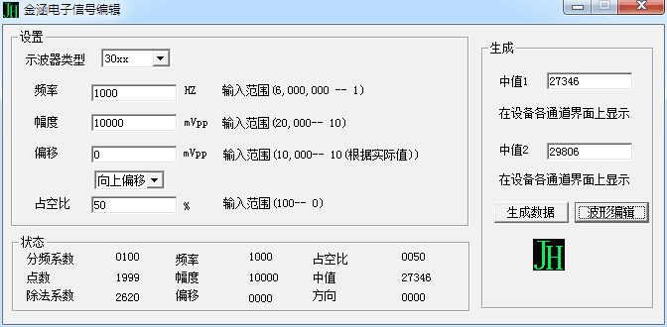
Fill in the parameters you want according to the interface and fill in the median 1 and median 2. These two values are described above (you can also use the default value without filling, but the output accuracy is not guaranteed).
After the parameters are filled in, click the Generate Data button. After the data is generated, click the Wave Edit button to enter the waveform editing interface.
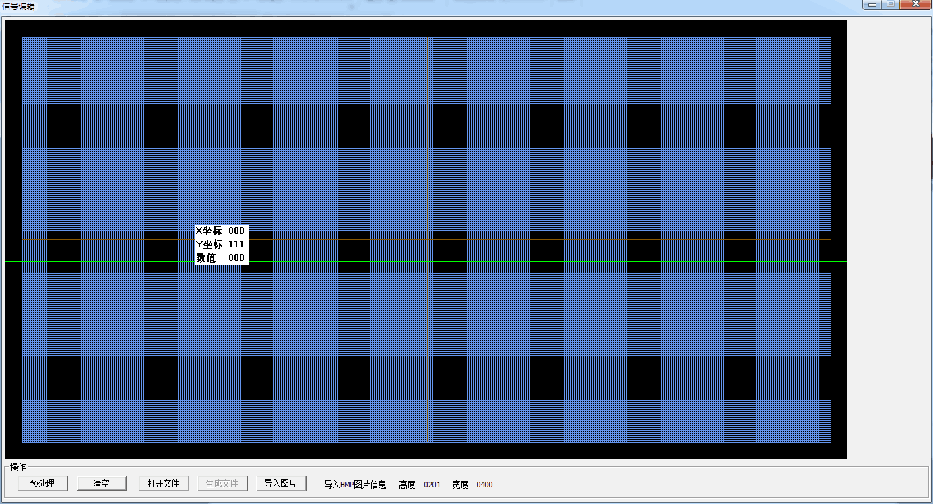
In the secondary interface, you can draw the waveform with the mouse, draw the mouse with the left mouse button, and clear the right mouse button.
After the waveform is drawn, click the pre-processing button, and then click to generate the file (the file name must be bx+number (corresponding to 0-97 custom waveform number).txt).
Copy the generated bx(n).txt file to the U disk that comes with the machine. After booting, enter the custom interface and select the corresponding number. Press OK to output.
Waveform editing can also be done with other graphics software (in other drawing software, you must select the white background and use the black pen to draw, otherwise it will not be recognized).
There is such a display in the interface for compiling the waveform:
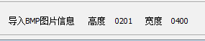

According to this information, can be in other graphics software in the new high of 201, 400 drawing wide area and draw the waveform in the area. After the drawing is completed, the file can be saved into a 16-bit bmp file in 565 format.

At this time, select import image in the waveform editing interface.
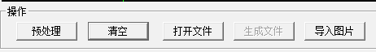
After the import is successful, click the pre-processing button and save the file.
Open the file to modify the waveform of the generated bx(n).txt file (note that the waveform can only be changed without changing the parameters).
