目录
SMTO502s series manual 2
1.Operation guide: 2
1.1 Operating area 2
1.2 Multi-point gesture operation 3
1.2.1 Two-point gesture operation 4
1.2.2 Three-point gesture operation 5
2. Interface description: 5
3. Oscilloscope instructions: 7
3.1 STOP key: 7
3.2 Trigger option key: 8
3.3 Time base button: 9
3.4 Oscilloscope-signal generator switch button 9
3.5menu: 10
3.5.1 Mathematical calculation 10
3.5.2 Ruler menu: 11
3.5.3 Parameter display: 11
3.5.4 Function options: 12
3.6 C1Channel menu 13
3.7 C2Channel menu 14
4. Signal generator instructions: 15
5. Screenshot 15
6.Program upgrade 15
7.Oscilloscope parameters: 16
8.Signal generator parameters: 17

SMTO502s series manual

1.Operation guide:

1.1 Operating area
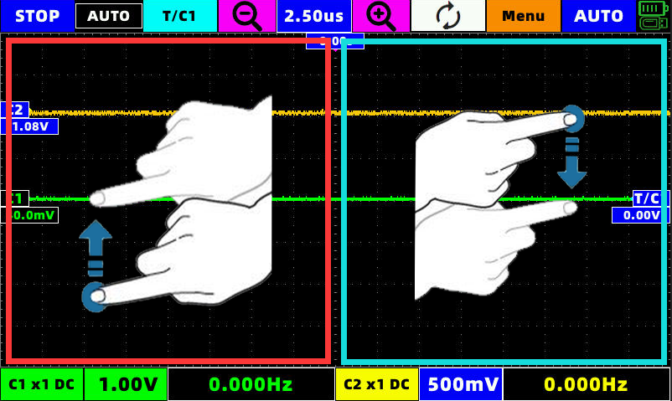
In the red area in the figure, slide up and down with a single finger, and the operability icon is C1,C2,V1
In the blue area in the figure, slide up and down with a single finger, and the operability icon is T/C1,V2
Select the icon you want to slide to turn it blue (active), and slide your finger up and down anywhere in the corresponding operation area to move the icon.
The icon will move with the speed of the finger.

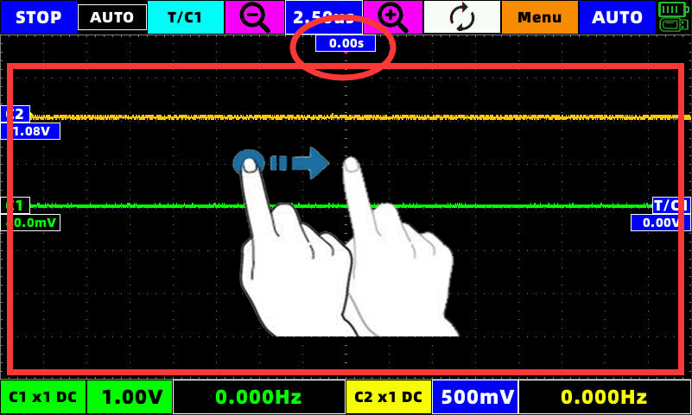
Swipe left and right with one finger in the red area in the picture, and the operability icon is T(Icon in red circle) S1,S2
Select the icon you want to slide to turn it blue (active), and slide your finger up and down anywhere in the corresponding operation area to move the icon.
The icon will move with the speed of the finger.

1.2 Multi-point gesture operation
This machine supports 2-point gesture operation and 3-point touch screen capture.

1.2.1 Two-point gesture operation
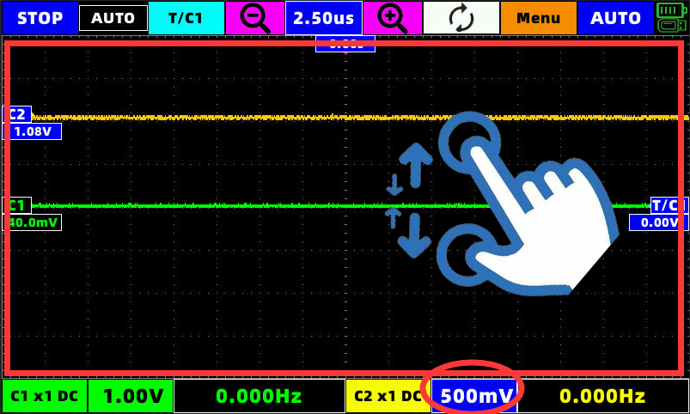
When the C1 or C2 channel is selected and the red circle turns blue, the two-point touch will take effect for that channel.
(Portrait) Two-point touch You can change the magnification of the waveform (that is, change the voltage gear)

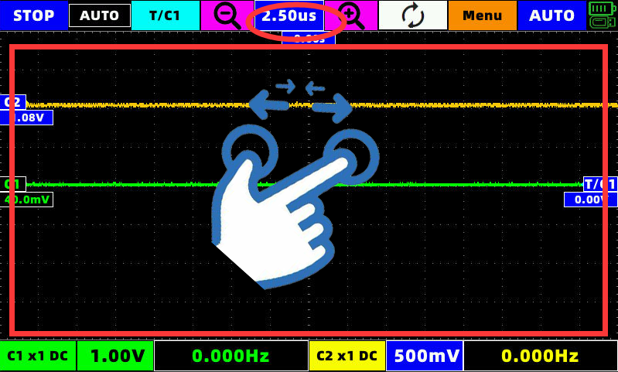
(Horizontal) Two-point touch The time base of the waveform can be changed (the value in the red circle in the figure)

1.2.2 Three-point gesture operation
After inserting the U disk, at any position on the screen, tap three fingers at the same time for 1 second after the buzzer sounds, a progress bar will appear, and the screenshot will be completed after the progress bar runs through the buzzer prompt.

Interface description:
Boot into the main interface:
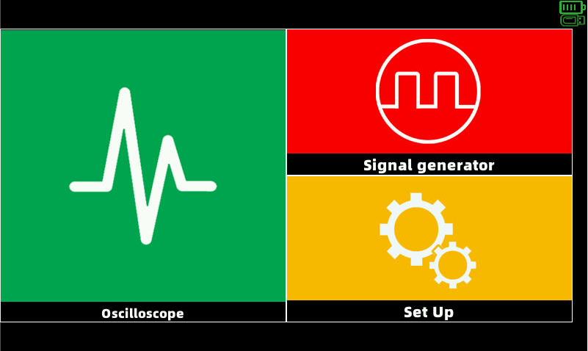
The main interface can choose oscilloscope, signal generator and setting interface.
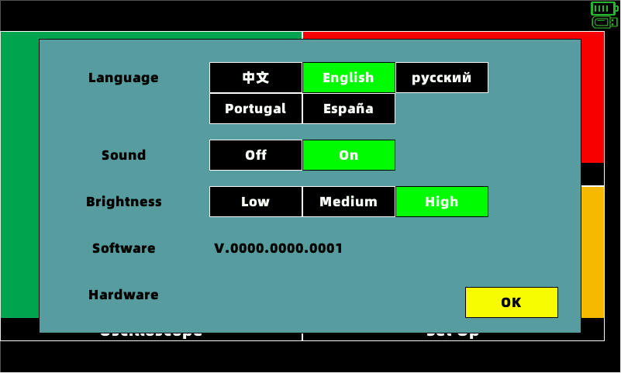
Click settings to see
Language selection, sound switch, brightness adjustment and software and hardware version number. You can modify it as needed.
Click on the oscilloscope to enter the oscilloscope interface:
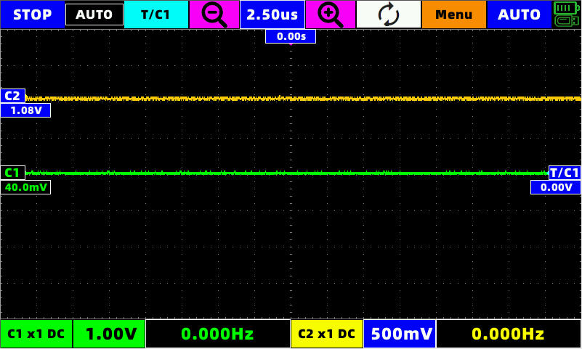
Click on the signal generator to enter the signal generator interface:
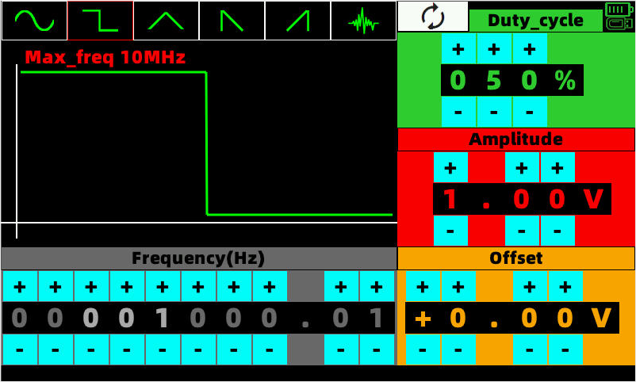

Oscilloscope instructions:

STOP key:
Press stop to stop the waveform, and the stopped waveform can be zoomed in and out to view the details. There is a small image of the original waveform in the upper left corner.
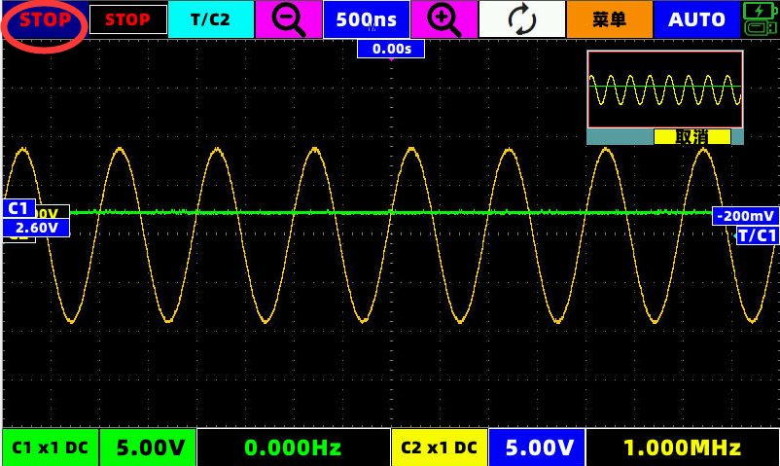

Trigger option key:
Click the red circle T/C1 button, and the trigger option will pop up

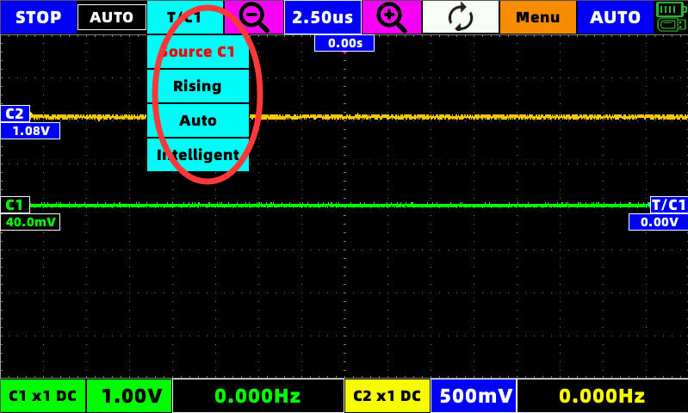
can choose
Signal source C1 or C2
Rising edge or falling edge
Auto trigger, normal trigger and single trigger
Smart trigger or manual trigger
Note: There is no need to manually adjust the trigger position of the waveform under smart trigger, the program will automatically find the appropriate trigger position and trigger the waveform.

Time base button:
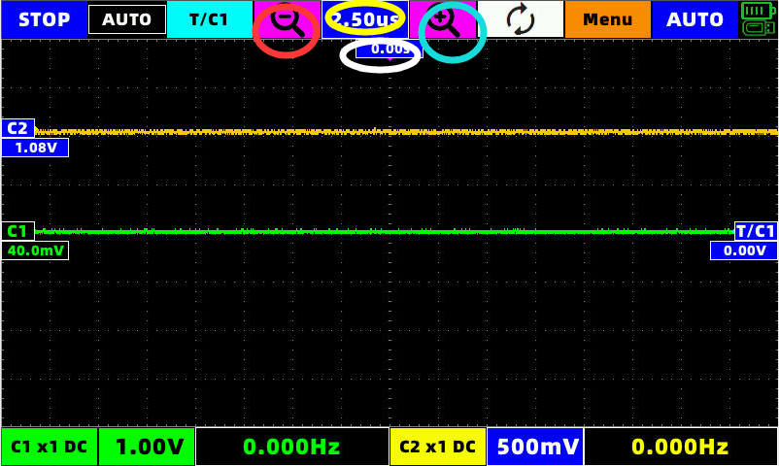
The button in the red circle in the picture is to reduce the time base, and the button in the basket is to zoom in the time base,While the button in the yellow circle displays the current time base value, the time position (that is, the parameter in the white circle) can be returned to zero with one key.

Oscilloscope-signal generator switch button
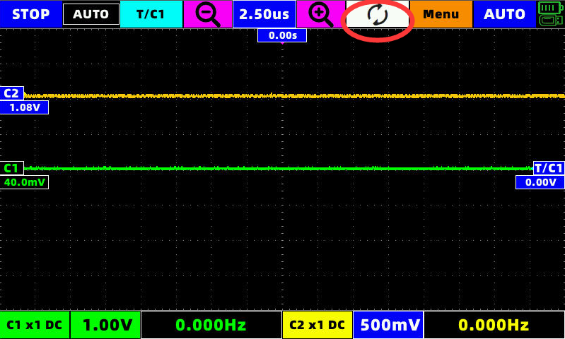
This switch key can switch between oscilloscope and signal generator with one key.

3.5menu:

3.5.1 Mathematical calculation
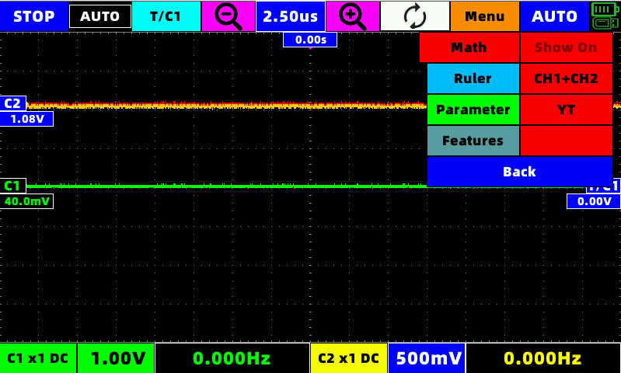
In this interface, you can choose to turn on or off the display of mathematical calculations, and you can choose YT or XY (Li Shayu) display mode
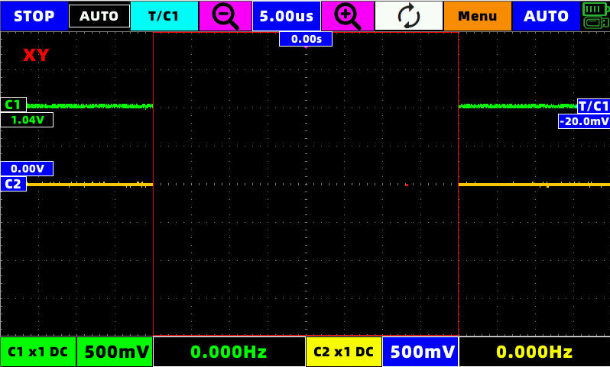

3.5.2 Ruler menu:
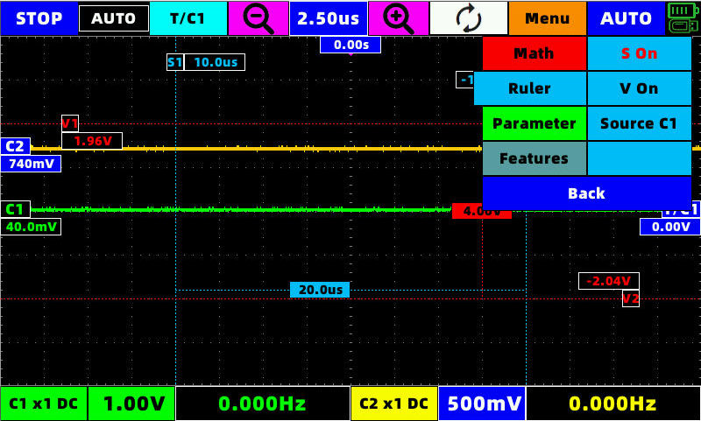
The horizontal and vertical rulers can be opened in this interface. As shown in the figure, the movements and selections marked follow the operation guide.
The signal source for simultaneous calculation can be C1 or C2

3.5.3 Parameter display:
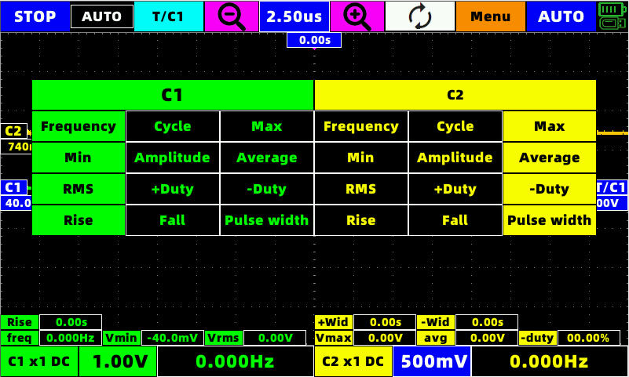
After opening the parameter display, you can select the parameter to be displayed by the corresponding channel, and the parameter will be displayed at the bottom of the screen.

3.5.4 Function options:
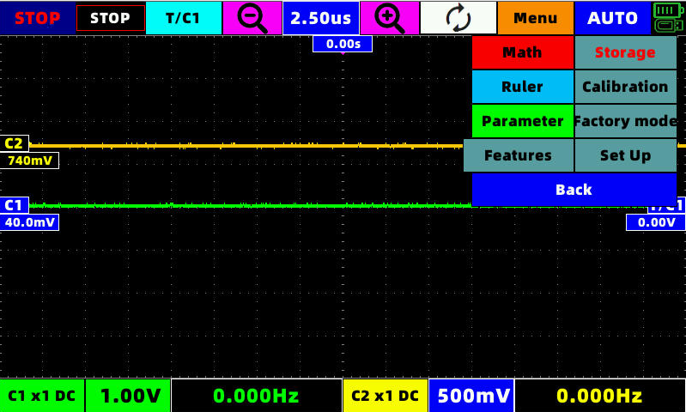

3.5.4.1Store waveform
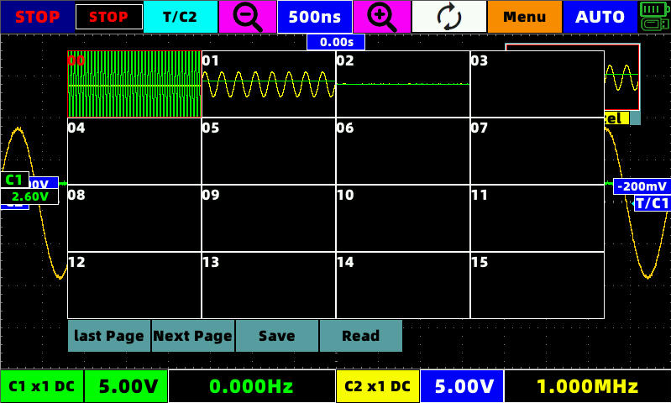
After clicking to store the waveform, the current waveform will automatically stop and enter the stop state.
In this interface, you can choose to save or read the waveform data of the previous waveform.
The read waveform data can be arbitrarily zoomed in and out to view the details, which is equivalent to the stop state.

3.5.4.2Automatic calibration
This button will automatically calibrate the oscilloscope parameters.
Warning! Do not operate the device during automatic calibration, and do not connect any external connectors!!!

3.5.4.3Restore Factory
This button will return the machine's settings and some parameters to the factory state.

3.5.4.4Set up
Equivalent to the settings of the main interface

3.5.4.5return
Can return to the main interface under the oscilloscope interface.

3.6 C1Channel menu
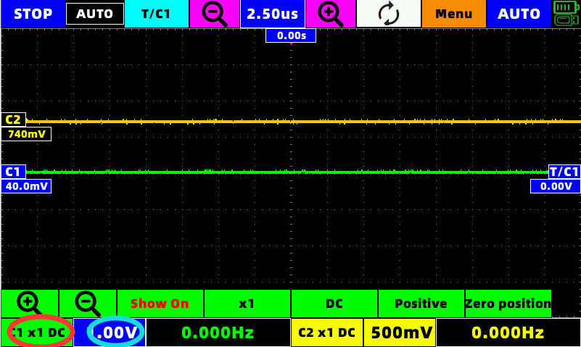
In this interface, you can zoom in and out the waveform voltage range of C1,
You can choose whether to display the C1 waveform
Select the X multiple of the probe
Choose AC, DC
Select whether the display of C1 waveform is inverted
The vertical position of C1 can be returned to zero with one key

The red circle in the picture can select the C1 channel, and the basket ring can quickly open or close the C1 channel

3.7 C2Channel menu
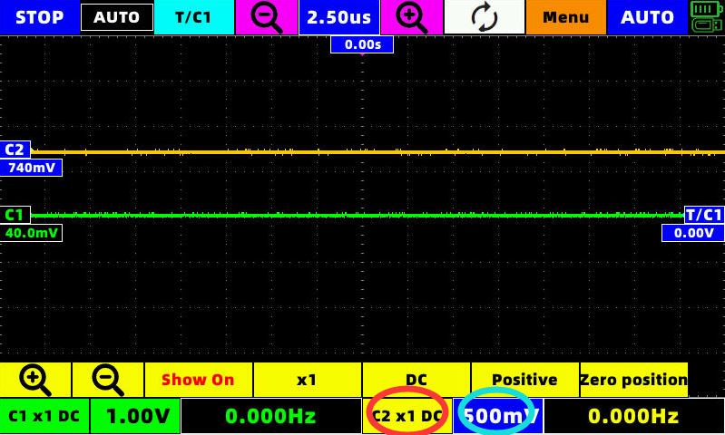
In this interface, you can zoom in and out the waveform voltage range of C2,
You can choose whether to display the C2 waveform
Select the X multiple of the probe
Choose AC, DC
Select whether the display of C2 waveform is inverted
The vertical position of C2 can be returned to zero with one key

The red circle in the picture can select the C2 channel, and the basket ring can quickly open or close the C2 channel

Signal generator instructions:
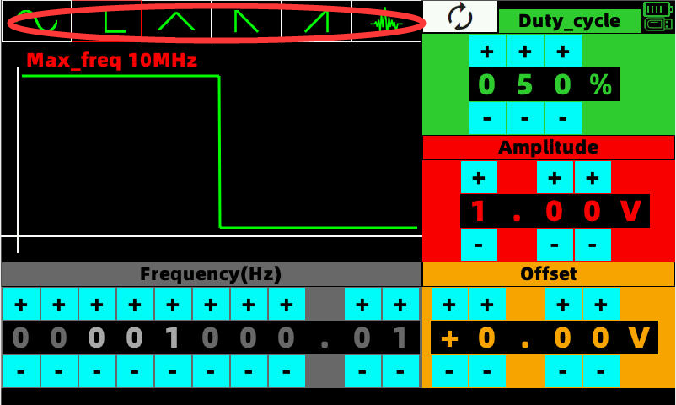
Through the corresponding +,-to modify the frequency, amplitude, offset, duty cycle and other signals, the waveform will be directly changed in real time.
The red circle area can select the waveform to be output.

Screenshot
After inserting the U disk, at any position on the screen, tap three fingers at the same time for 1 second after the buzzer sounds, a progress bar will appear, and the screenshot will be completed after the progress bar runs through the buzzer prompt.

6.Program upgrade
When the machine is turned on, insert the U disk containing the upgrade file, and then power on, the device will automatically enter the U disk upgrade program, click the upgrade button in the upgrade program, wait for the upgrade progress to 100% and automatically shut down.

Warning! Make sure that the battery level of the device is in the green mode when upgrading!!

7.Oscilloscope parameters:

Number of channels 2
Maximum sampling rate Dual channel 250MSa/s
bandwidth 60M
impedance 1MΩ 25pF
Storage depth Per channel32K
Vertical resolution 8bit
Vertical gear In the case of probe X1 10mV - 5V (1, 2.5 ,5 Stepping)
Maximum measuring voltage X1(40V) X10(400V)
Use high-voltage probes, the maximum voltage is determined by the quality of the probe
Horizontal gear 5s - 10ns (1, 2.5 ,5 Stepping)
5s - 100ms Scan mode
Automatic measurement parameters 13个
(Frequency, period, amplitude, maximum, minimum, average, effective value, positive duty cycle,
Duty cycle negative, positive pulse width, negative pulse width, rise time, fall time)
Trigger mode Automatic, normal, single
Trigger type Rising edge, falling edge
Auto range 50Hz - 30MHz
cursor Both vertical and horizontal support cursor measurement
Waveform record 32 groups (recording waveform supports zoom in and zoom out to view details)
Screenshot Support U disk screenshot (picture format jpg)
Mathematical calculation CH1+CH2,CH1-CH2,CH2-CH1
Display mode YT mode + XY mode (Li Shayu mode)
Automatic calibration stand by

display 7 inch capacitive touch screen
battery 5000mA large-capacity lithium-ion battery (full charge can be used for more than 5-6hours)
Recharge Maximum support 5V2.1A DC charging. (The light reflects the charging status in real time)

8.Signal generator parameters:

Amplitude: 0 V - 8V (Minimum resolution 10mV)
Offset: 0V - ( + - 4V) (The sum of half the amplitude does not exceed 8V)(Minimum resolution 10mV)
Duty cycle: 0% - 100% (Minimum resolution 1%)
frequency:
Sine wave: 0.01Hz - 30Mhz (Minimum resolution 1/1000)
Fang Bo: 0.01Hz - 10Mhz (Minimum resolution 1/1000)
Other waveforms (triangular wave, sawtooth wave, ringing wave):
0.01Hz - 1Mhz (Minimum resolution 1/1000)

